

**Project Database Systems**

***Spring-2025 Department of Computer Science***



***03- June-2025***

***Submitted By:***

*Hassan Raza*

Roll No. F24BDOCS1M01442

*Subject: Database*

BSCS (2nd Semester)

Section 7M

***Submitted To:***

*Professor Muhammad Usman Ghani.*

**Title: University Professors and Organizations Management System.**

**Introduction:**

* 1. **Background:**

In universities, many professors work with different organizations. But managing all this data manually is hard and confusing. So, we created a database that stores information about **universities**, **professors**, and the **organizations** they are connected to. This helps keep everything in one place, neat and easy to access.

* 1. **Goal:**

The goal of this project is to:

* Save data about universities and professors.
* Show which professor is connected to which organization.
* Make it easy to **search**, **add**, **update**, or **delete** any data.
  1. **Requirements:**
* What users need from this system:
* Save basic info about universities (like name and city).
* Store professor details (like their name and which university they belong to).
* Keep records of organizations (like name and sector).
* Connect professors to the organizations they work with.
* Make sure all the links between tables are correct and no data is lost.

1. **Functional Description:**
   1. **Method of use:-**

This system will be used by:

* **University staff** to manage professors.
* **Students** to see where professors work or do research.
* **Database admins** to maintain clean and correct data.

1. **Entity Data Model:-**

We have 4 main tables:

1. **Universities** – Stores university names and cities.
2. **Professors** – Stores professors' first and last names, and their university.
3. **Organizations** – Stores details about companies or research centers.
4. **Affiliations** – Connects professors with the organizations they work with.

#### 

#### Relationships:

* Professors are connected to one university.
* Professors can work with one or more organizations.
* Each connection between a professor and an organization is saved in the "affiliations" table.

#### Table Design (Schema) Screenshots

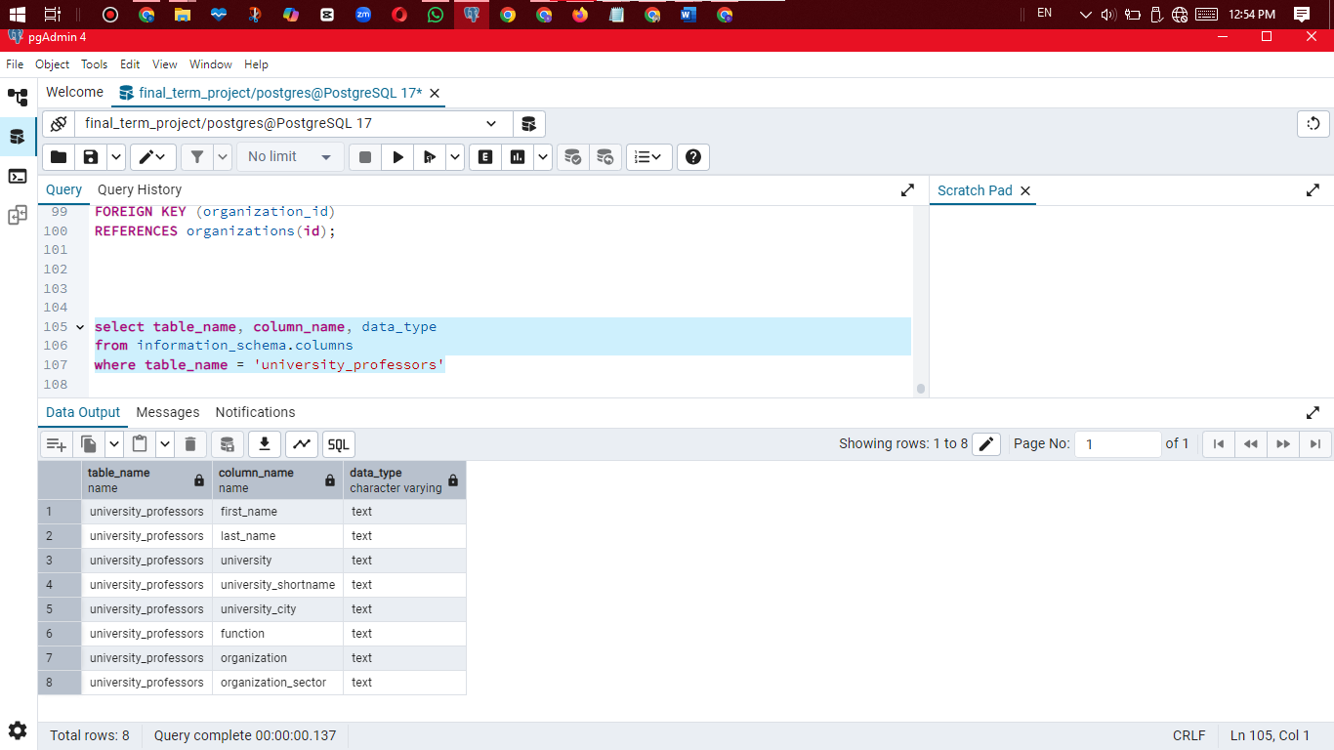

**Summary of Normalized Schema:**

* **professors**: Basic identity, linked to university.
* **universities**: Info about the university.
* **organizations**: External bodies professors are affiliated with.
* **affiliations**: Links a professor to an organization with a role.

1. **Frontend Screenshots**

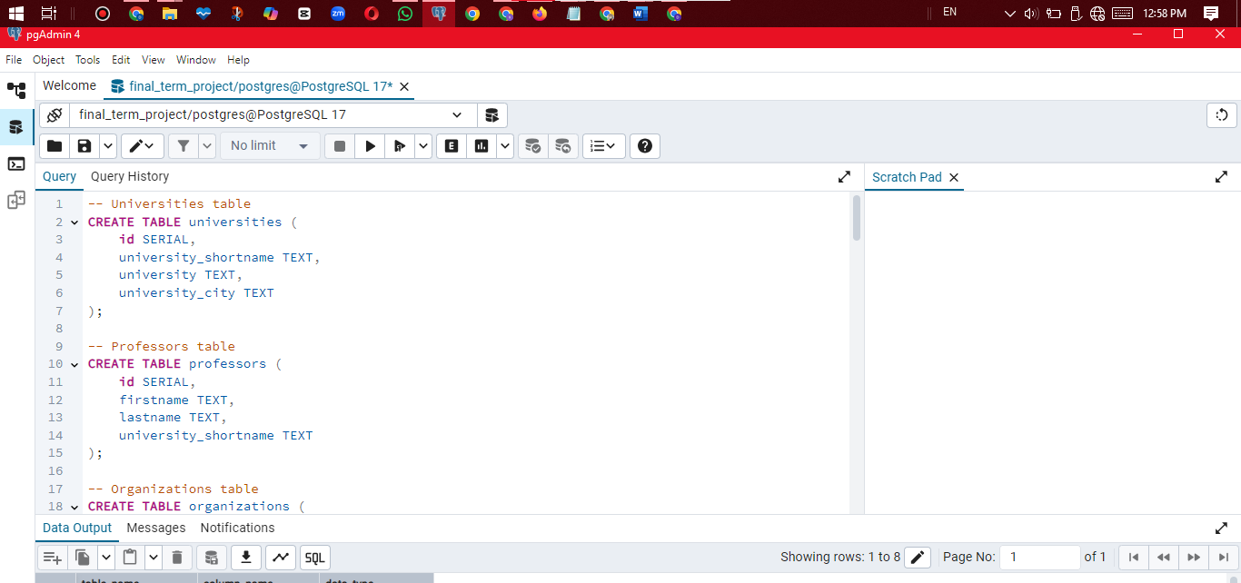Creation of data:

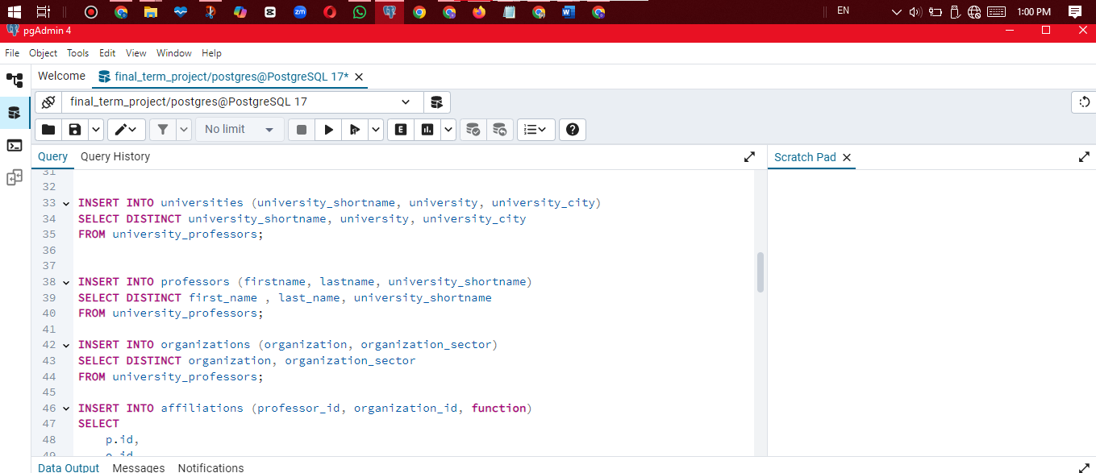Insertion of data:

Build a Relationship:

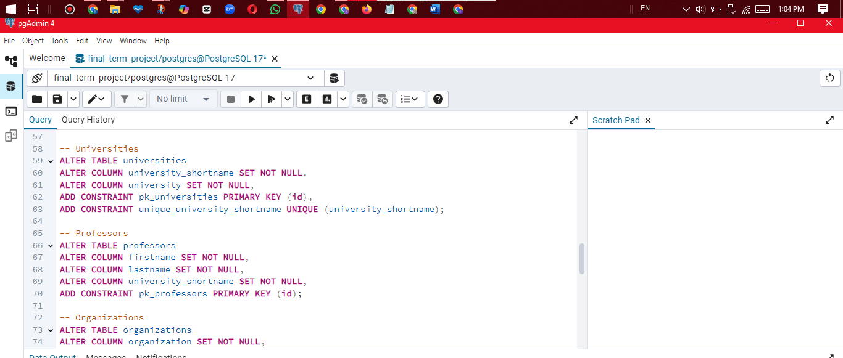

1. **Example query:**

* 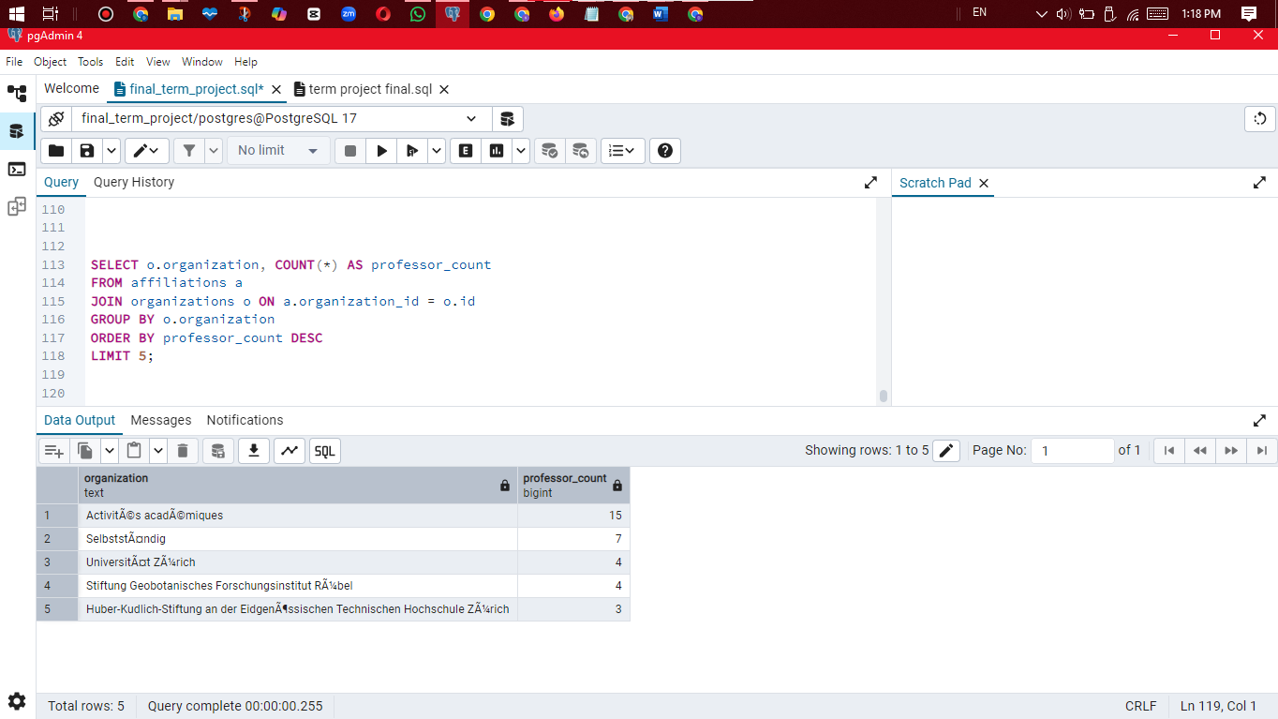**Count how many professors are in each organization**
* **Update table:**

UPDATE professors

SET firstname = 'John'

WHERE firstname = 'Jon';

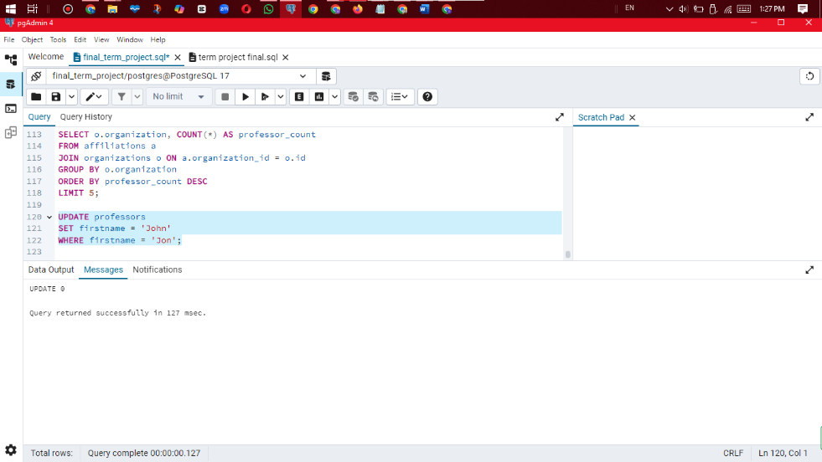

**JOIN Example:**

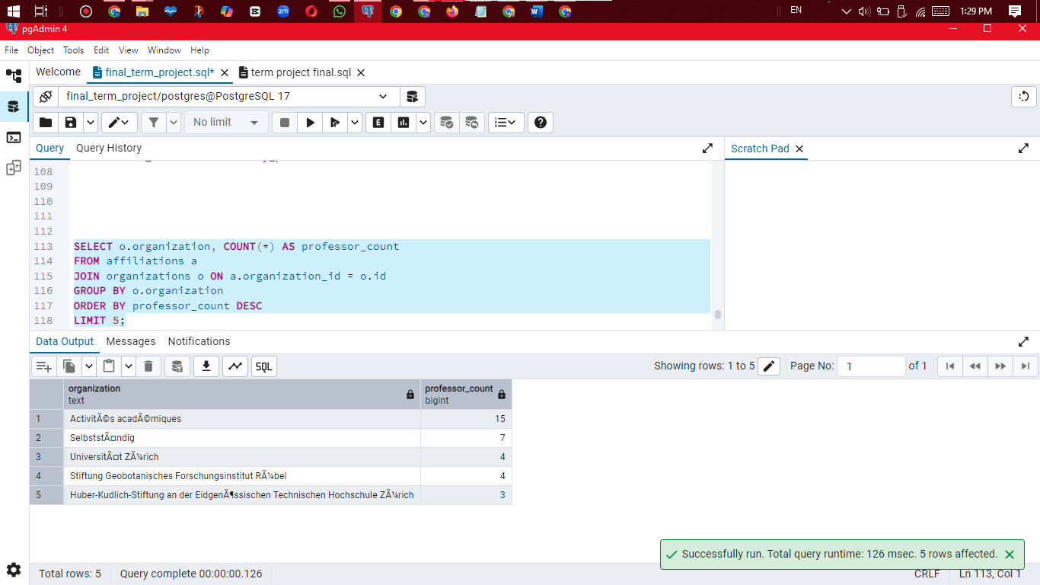

SELECT o.organization, COUNT(*) AS professor_count

FROM affiliations a

JOIN organizations o ON a.organization_id = o.id

GROUP BY o.organization

ORDER BY professor_count DESC

LIMIT 5;

1. **Referential Integrity:**

We added **foreign keys** to make sure:

* Professors must belong to a valid university.
* Affiliations must link to real professors and organizations.

This keeps the data **correct** and **connected**.

1. **Project Files**

(Provide github link):

https://github.com/hassanraza1442/Database-final-term-project-